­ Intellij download community free edition

Setup lambok in your project STS

* <https://projectlombok.org/setup/maven>
* https://mvnrepository.com/artifact/org.projectlombok/lombok/1.18.24
* <dependencies>
* <dependency>
* <groupId>org.projectlombok</groupId>
* <artifactId>lombok</artifactId>
* <version>1.18.24</version>
* <scope>provided</scope>
* </dependency>
* </dependencies>

Click on jar :

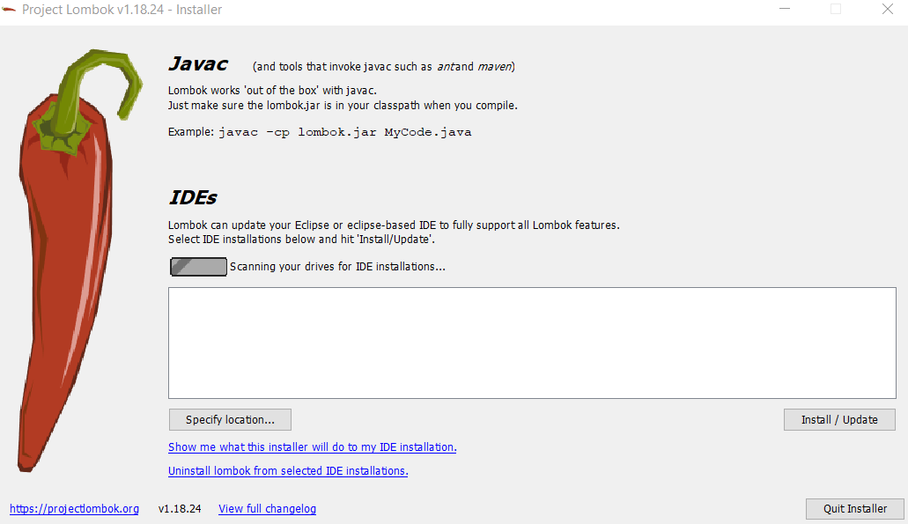

Click on specify location - E:\software\STS\sts-4.12.0.RELEASE

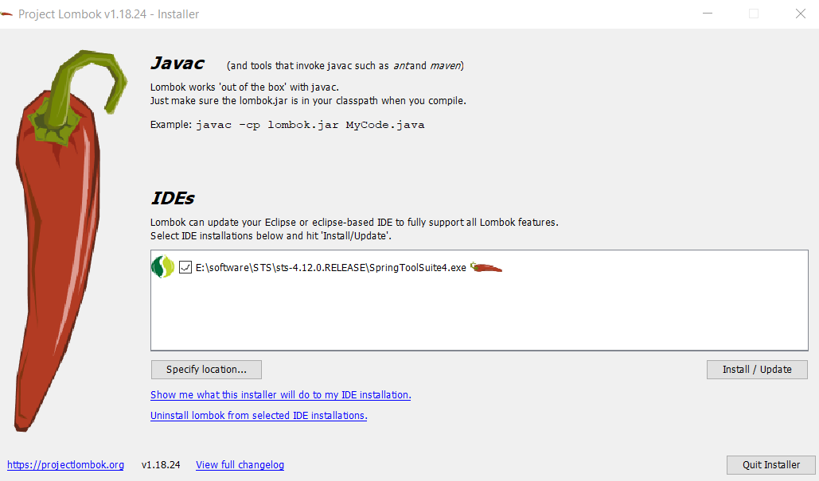

Click to install

Lambok added to your specified location :

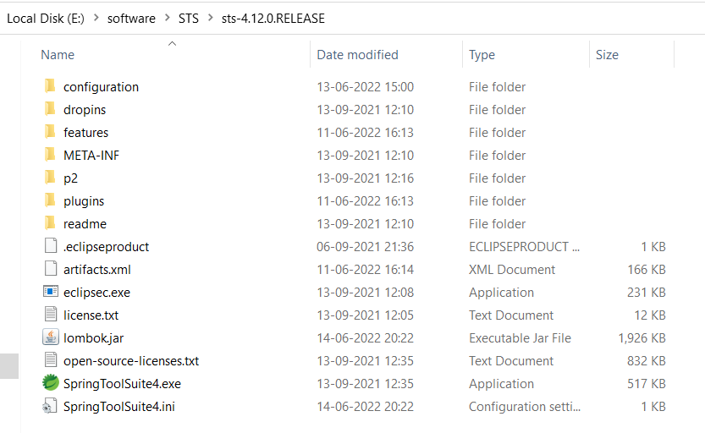

Check in your sts ini file – lambok.jar is added

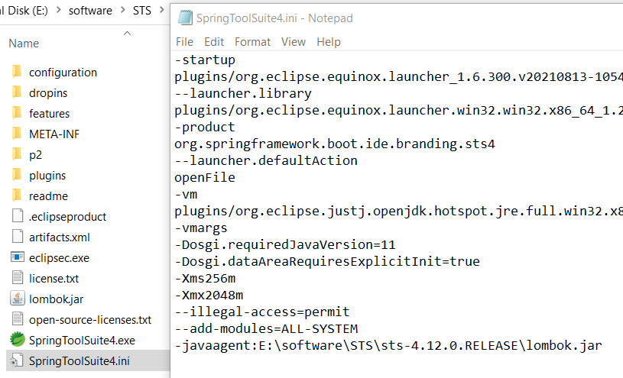

* Launch STS
* After that don’t select anything just finish and then manully add dependency of lambok
* We use lambok when we want create models for objects
* We have @Setter, @Getter, @AllArgsConstrutor and @EqualAndHashCode
* If we don’t to use above method then use -> single @Data

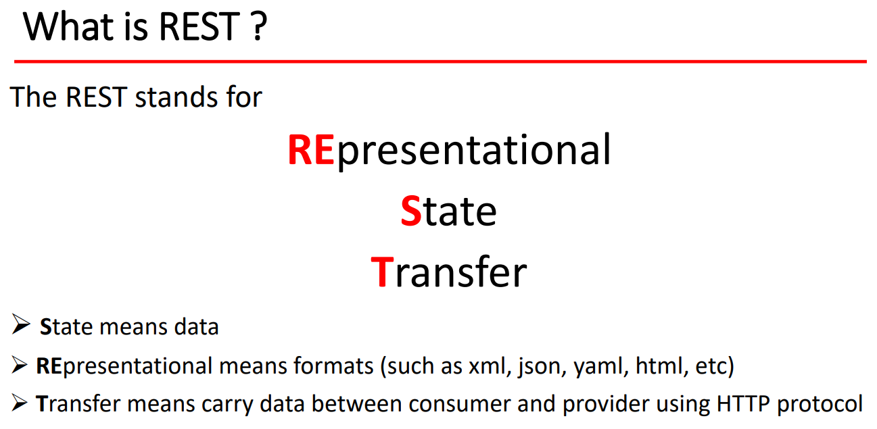

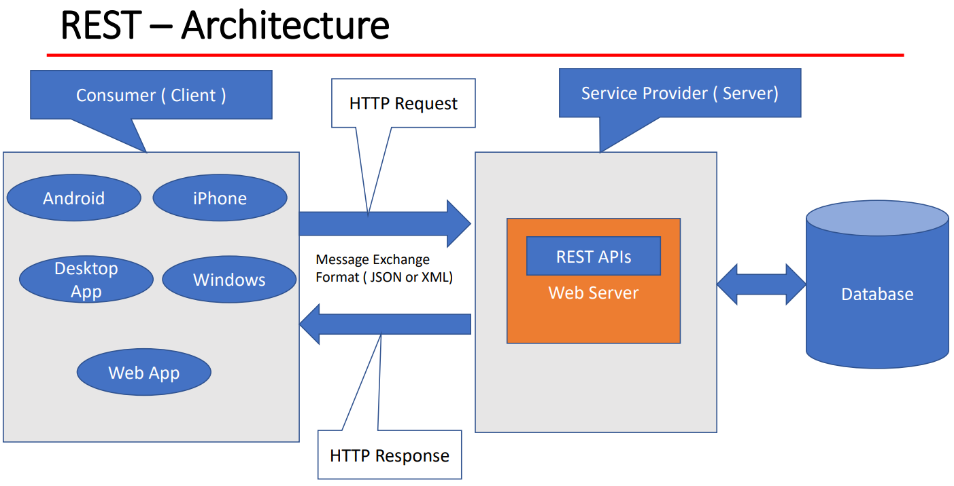

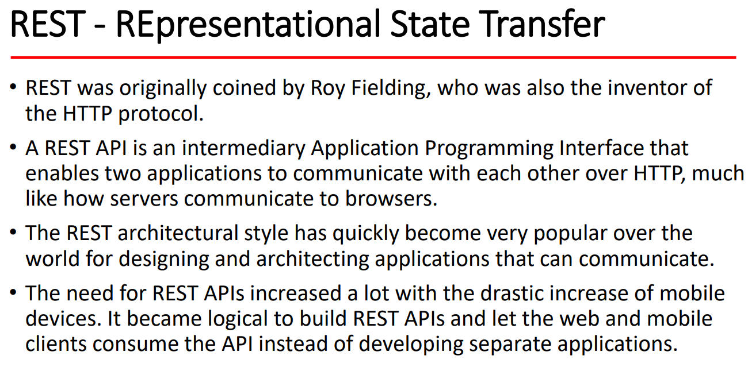

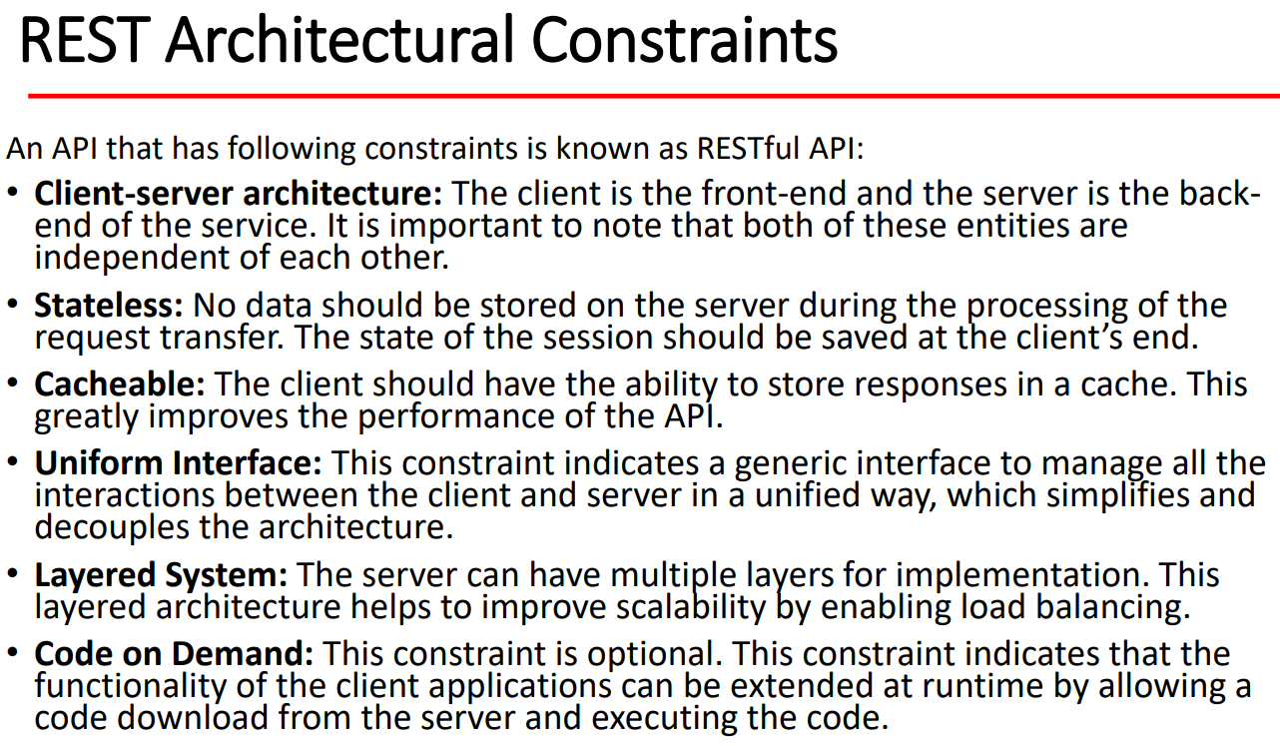

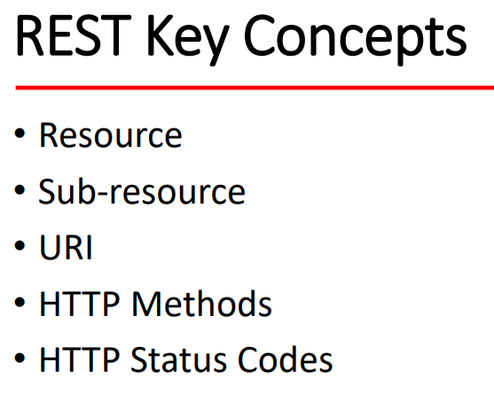

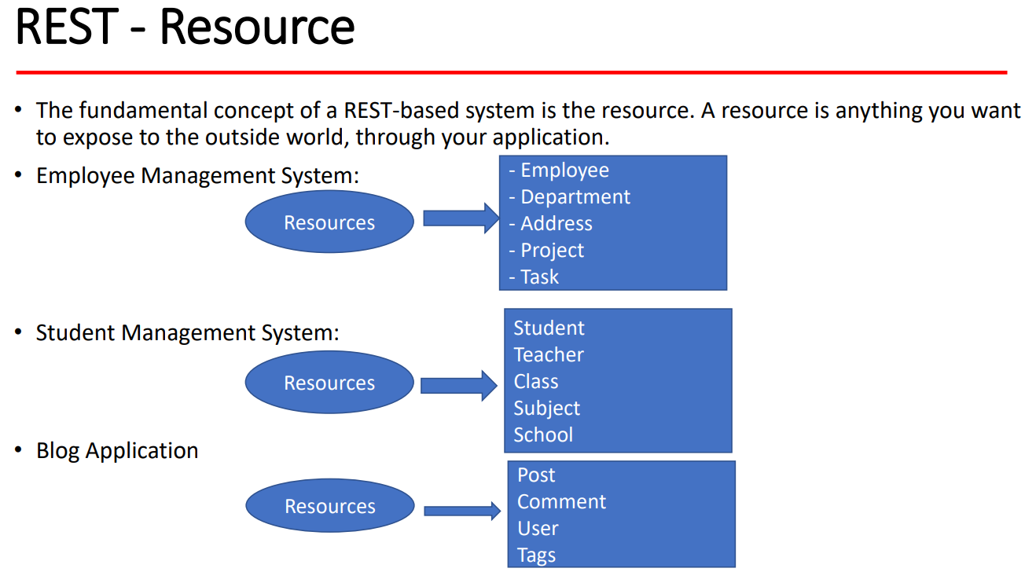

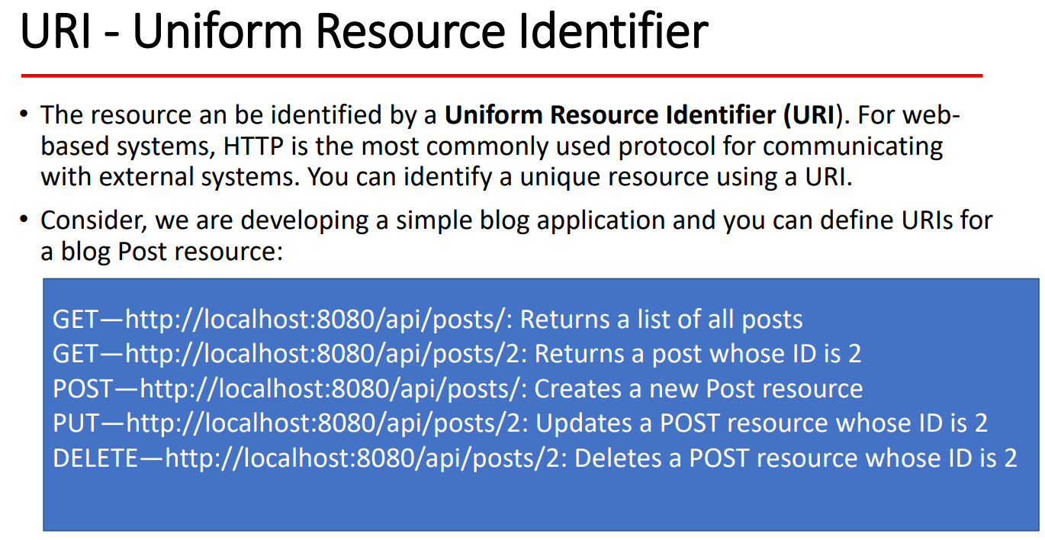

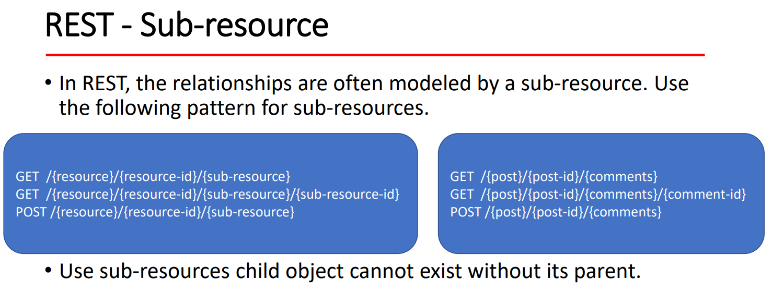

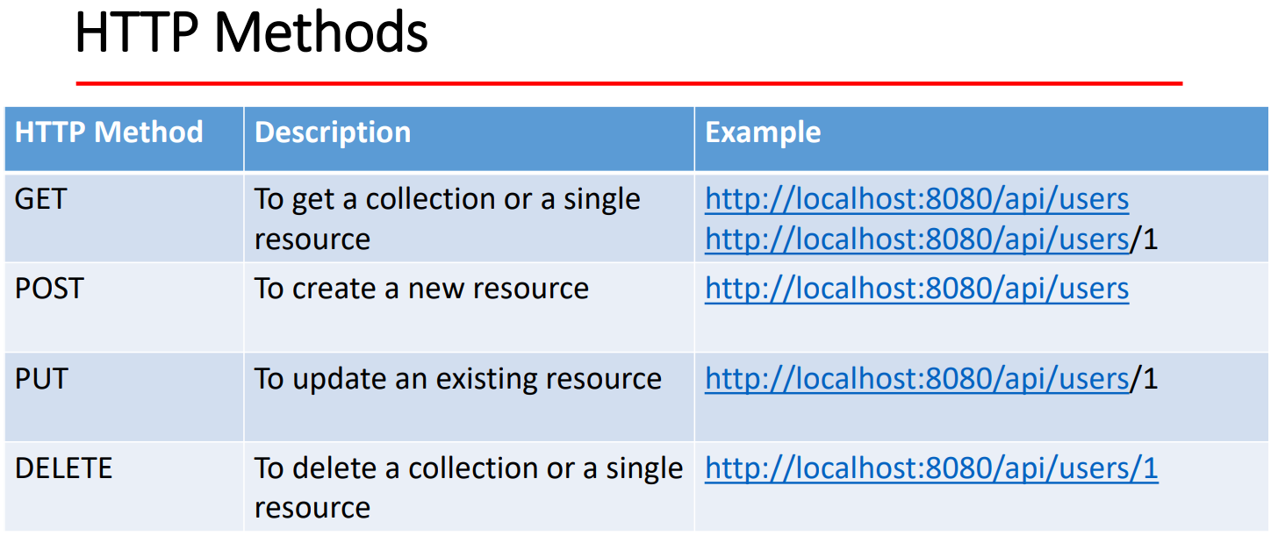

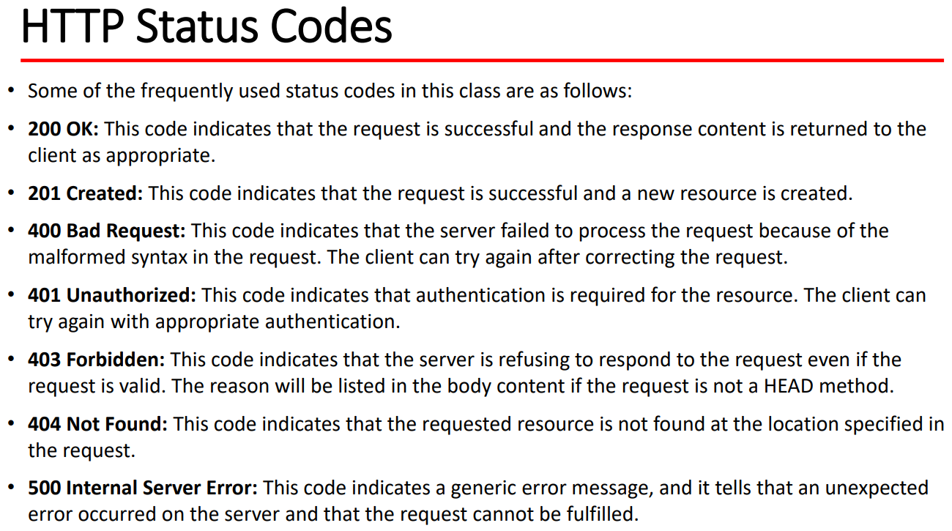

**REST API Design Best Practices**

# 1. Use Nouns for Resource Identification

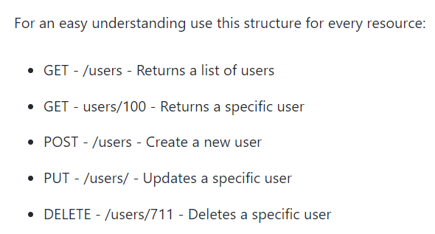

# 2. Use Plural Nouns to Name a Resource

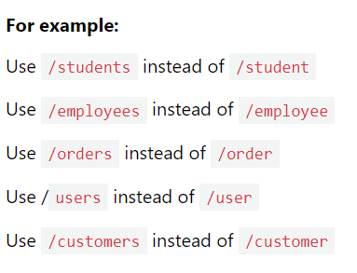

# 3. Use Sub-Resources for Relations

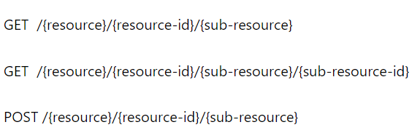

Blog Application:

1. Build Rest API for pagination and sorting on post
2. Build Rest API for login and signup
3. Build Rest API for exception or error handling
4. Build Rest API for request validation
5. Secure Build Rest API for role base security – admin and user
6. Use taken based authentication
7. Document all REST API for consumers
8. Deploy blog app production

Technical Stack :

1. Spring boot
2. Spring framework
3. Spring security (JWT)
4. Spring JPA
5. Maven
6. Java 8+
7. Build tool : Maven
8. REST Client:Postman
9. REST API doc : Swagger
10. Production :AWS
11. Database : mysql

Resources for Blog application:

1. POST
2. Comment
3. User

Post man client -> controller -> services -> dao layer -> database

Steps :

1. First identify resources
2. Write down all endpoints what you want – rest api design

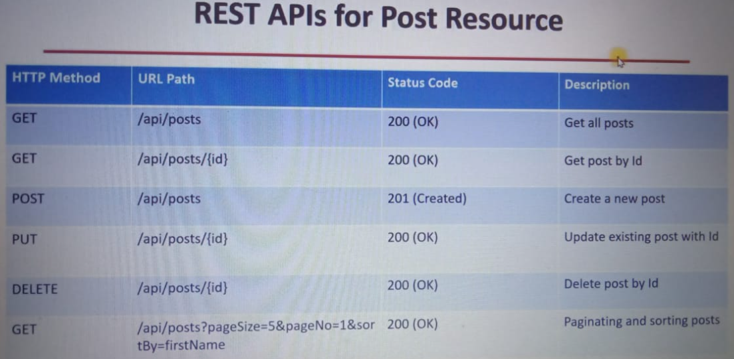

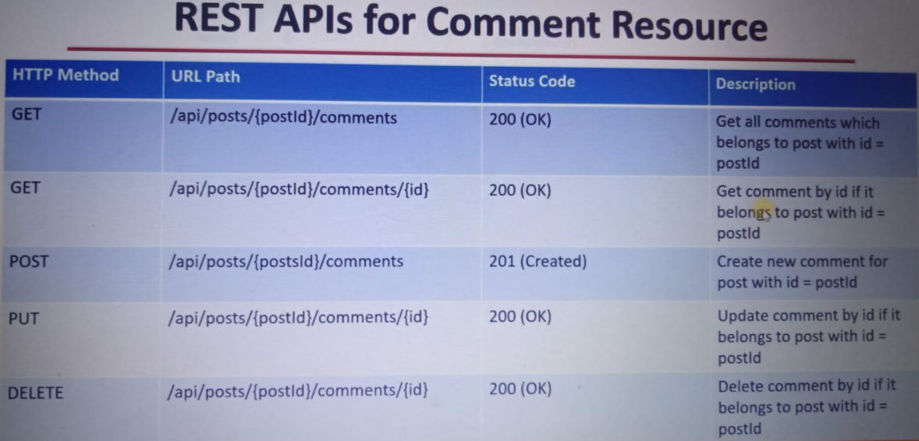

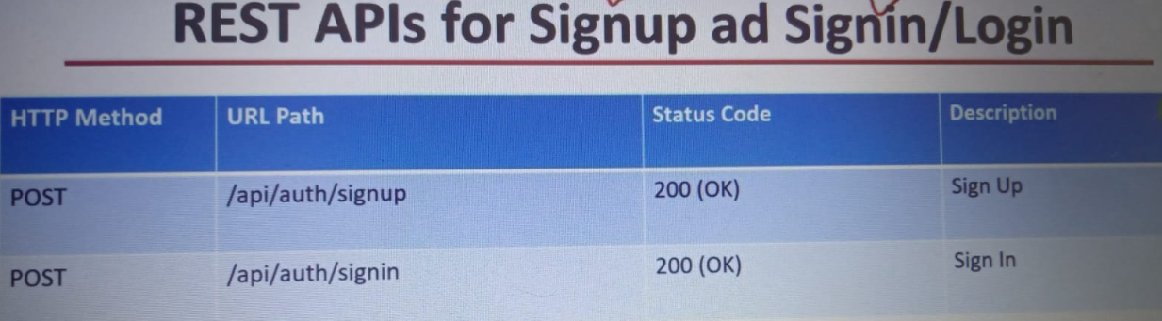

1. Setup project with spring initializer
2. Make packaging structure like 3 layer arch
3. Setup all properties in application for hibernate and mysql
4. Run and see
5. Create entities for post
6. Create spring jpa repository for post

* 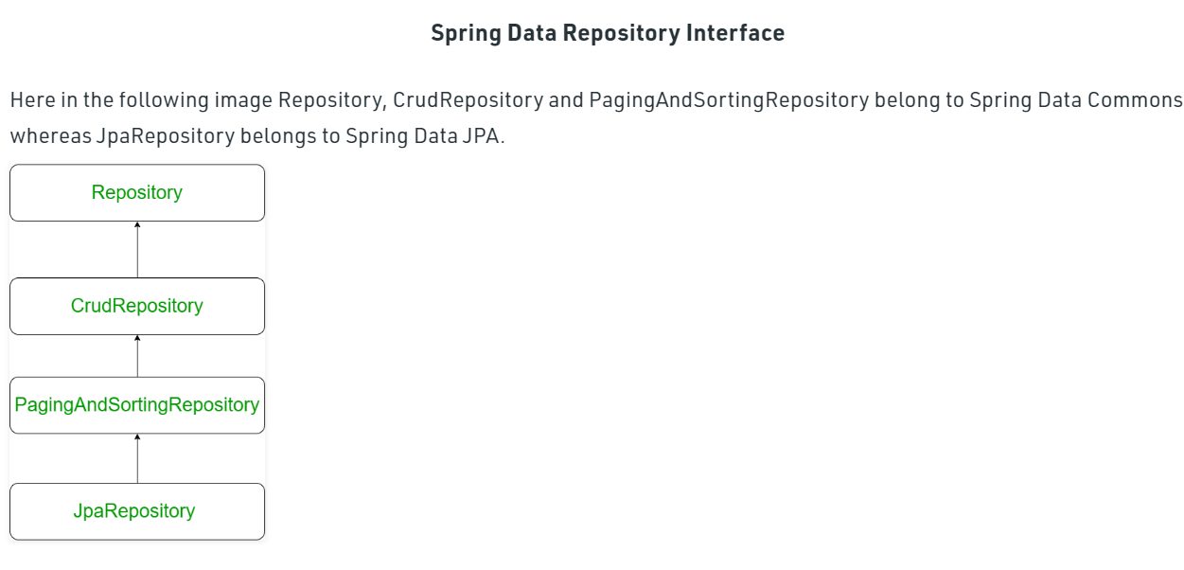

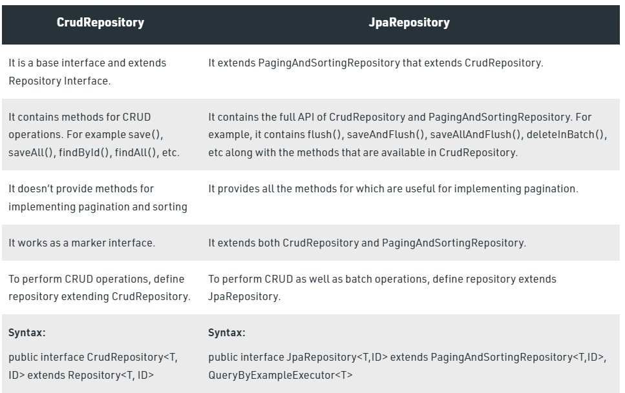

// Repository -> CrudRepository -> PagingAndSortingRepository -> JpaRepository  
// no need to annotated this interface as @Repository => SimpleJpaRepository is class internally using @Repository  
// annotation so no need to write here.

1. Create custom exception for resource - whenever our resource is not found then it should response with https code not found

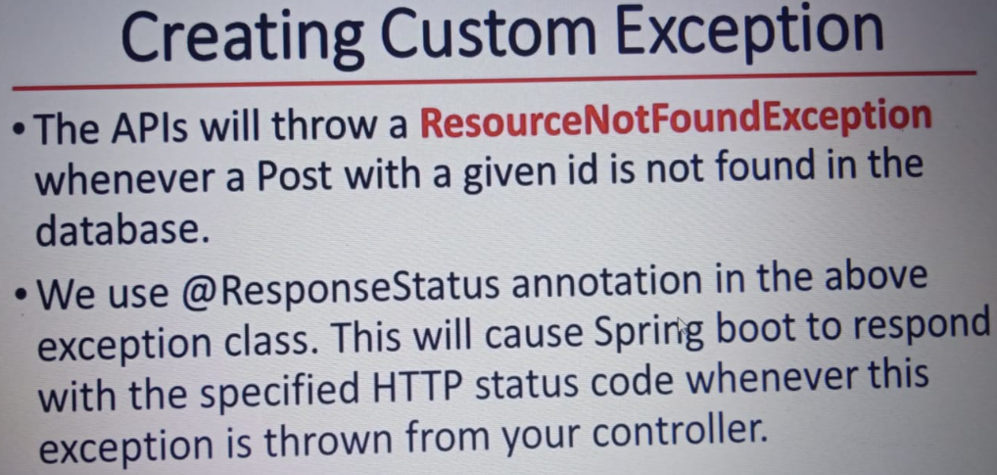

1. Create DTO – data transfer object -> send data from client to server or vice versa.

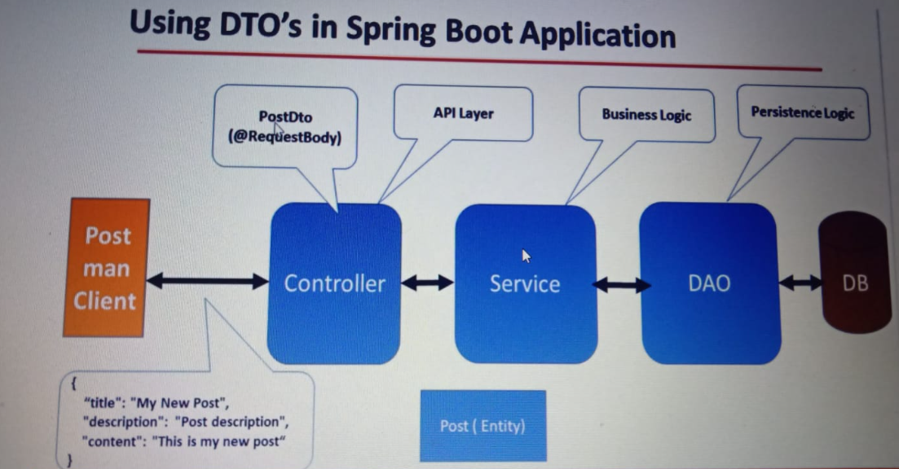

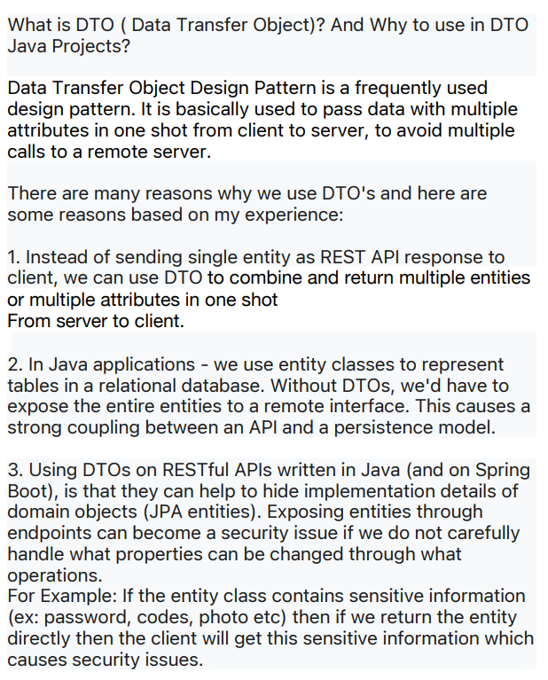

1. Create postService interface and impl also and write create post service using DTO
2. Create controller on post controller – first to write for create post,update,delete and get post

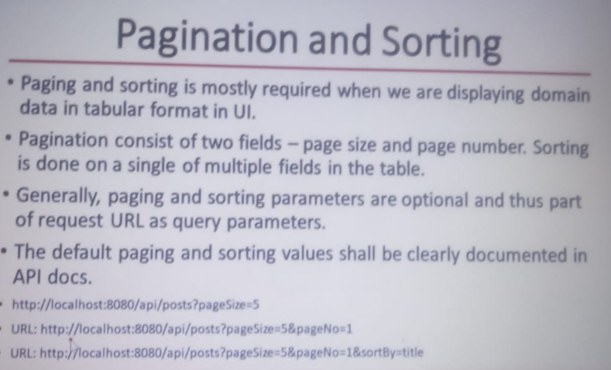

1. Done with all pagination and sorting on post
2. Done with all comment – post, update, delete, get
3. Modal mapper library or model struct

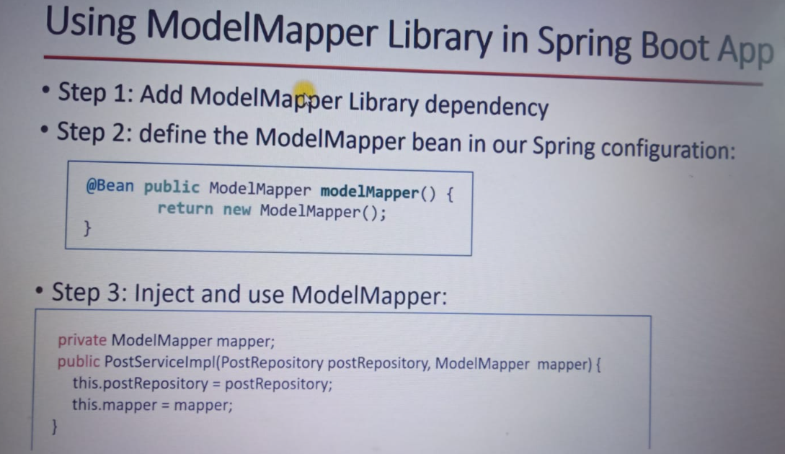

<!-- https://mvnrepository.com/artifact/org.modelmapper/modelmapper -->

<dependency>

<groupId>org.modelmapper</groupId>

<artifactId>modelmapper</artifactId>

<version>3.1.0</version>

</dependency>

1. Exception handling

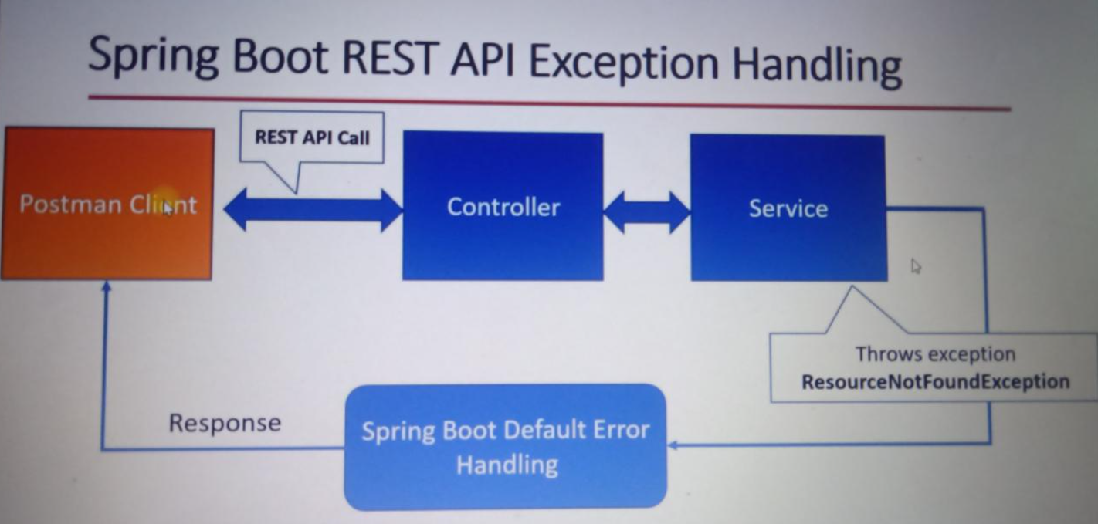

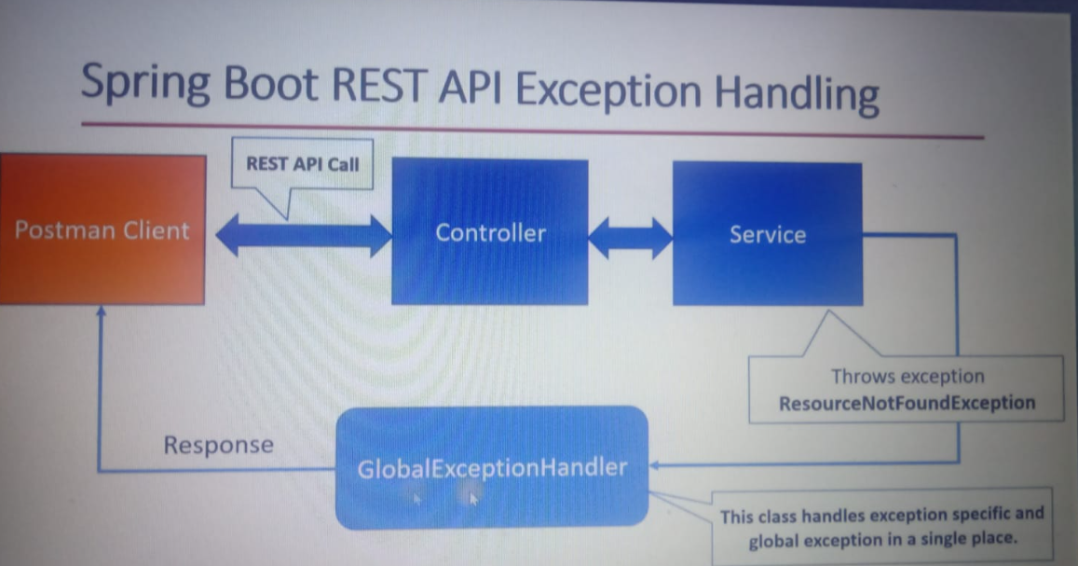

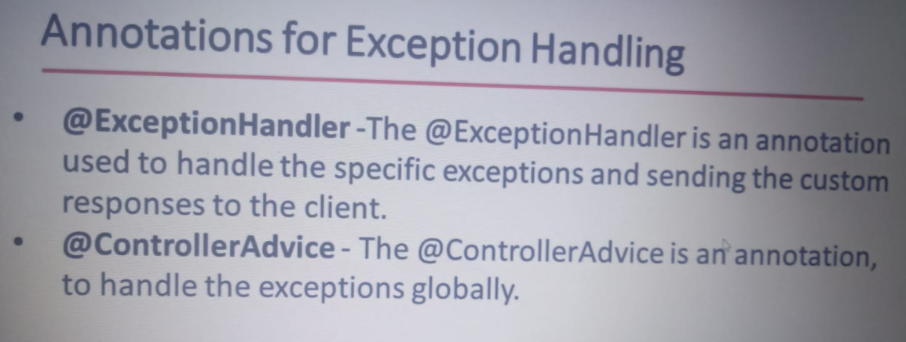

13.

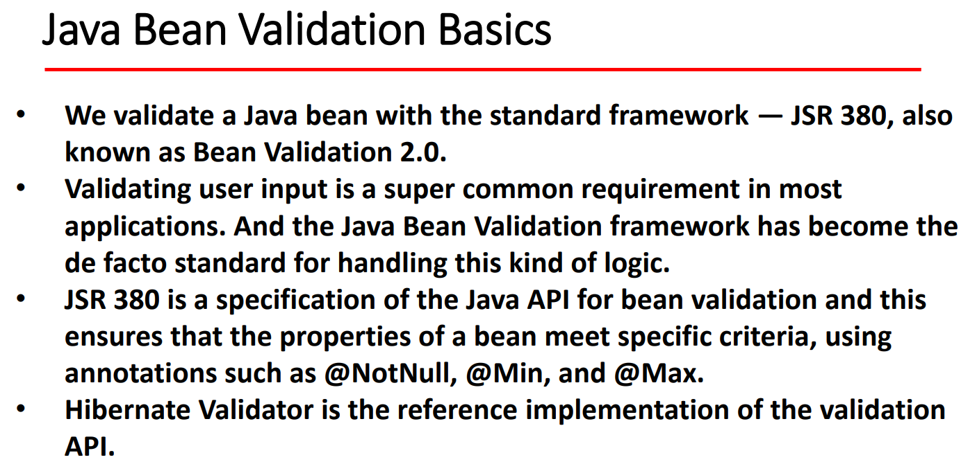

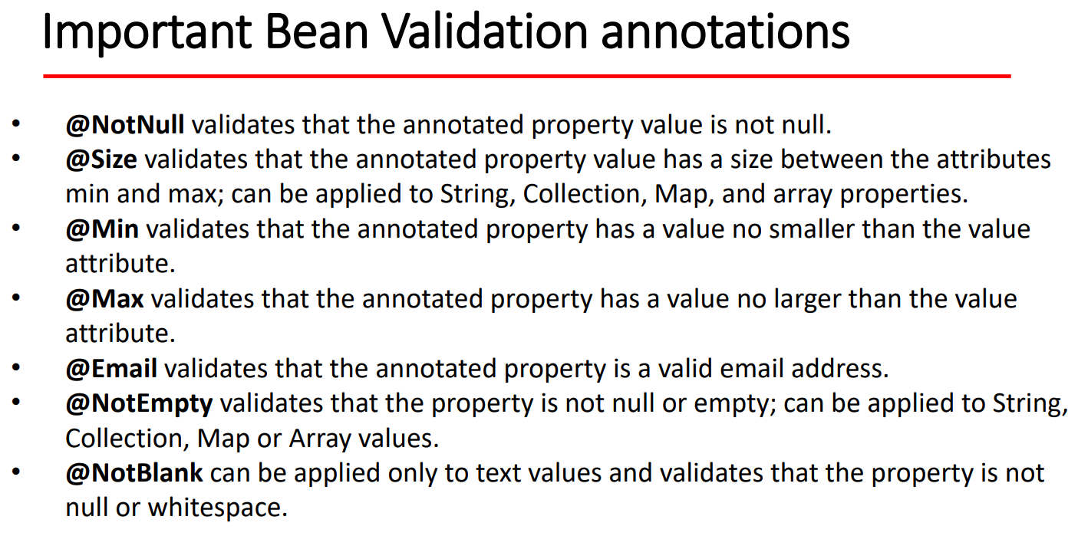

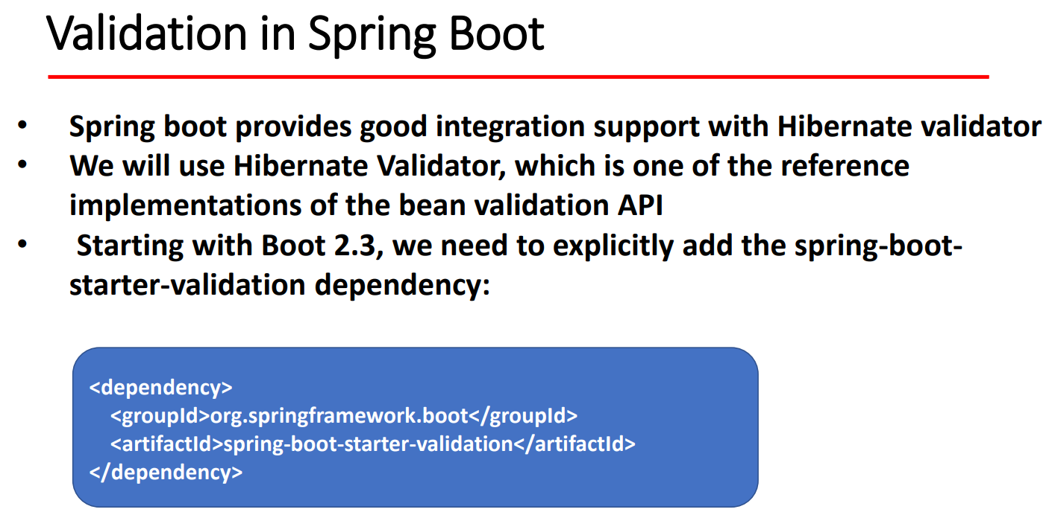

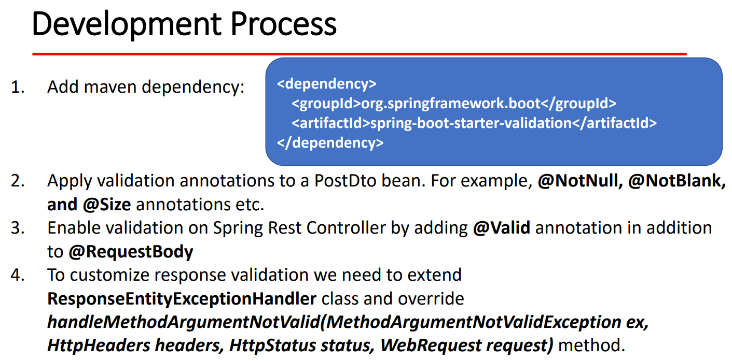

* Customize validation response

1. Security to rest api

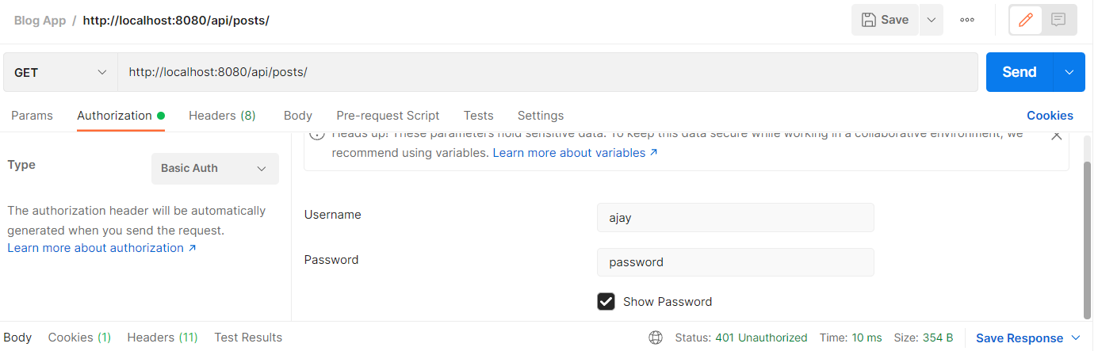

Check with rest api with roles of users

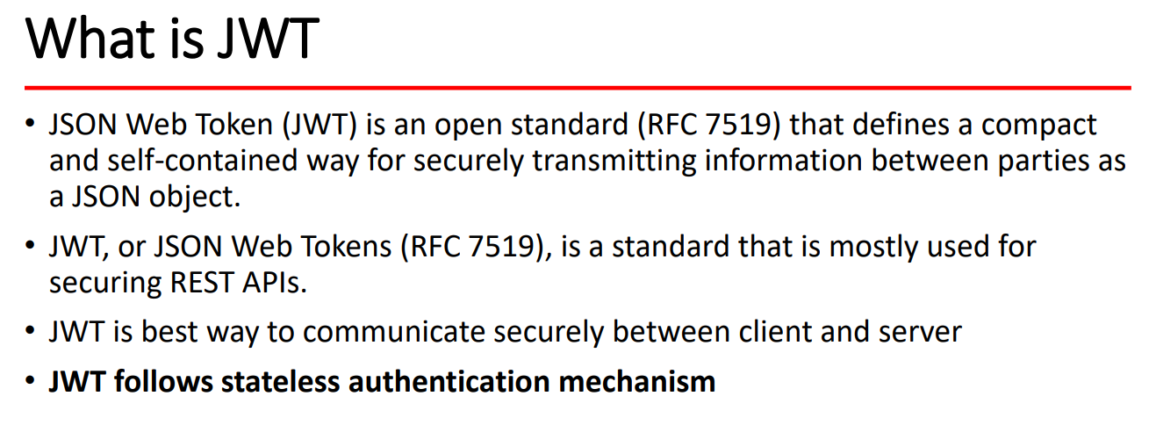

We don’t want to store any session information at server side that is called stateless .

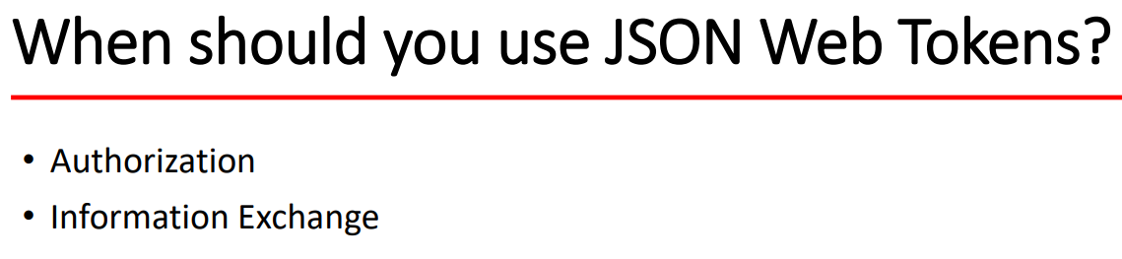

Authorization – means person can get resource only when token is valid.

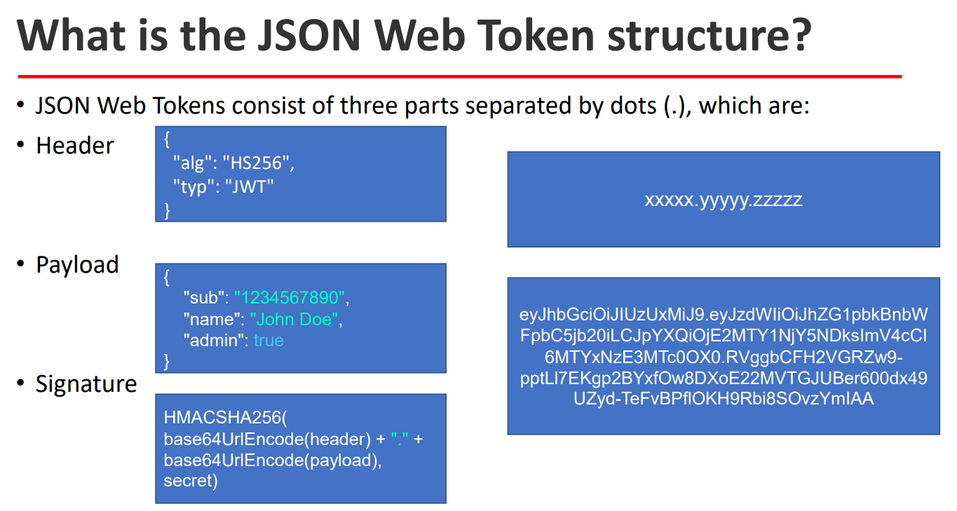

[www.jwt.io](http://www.jwt.io)

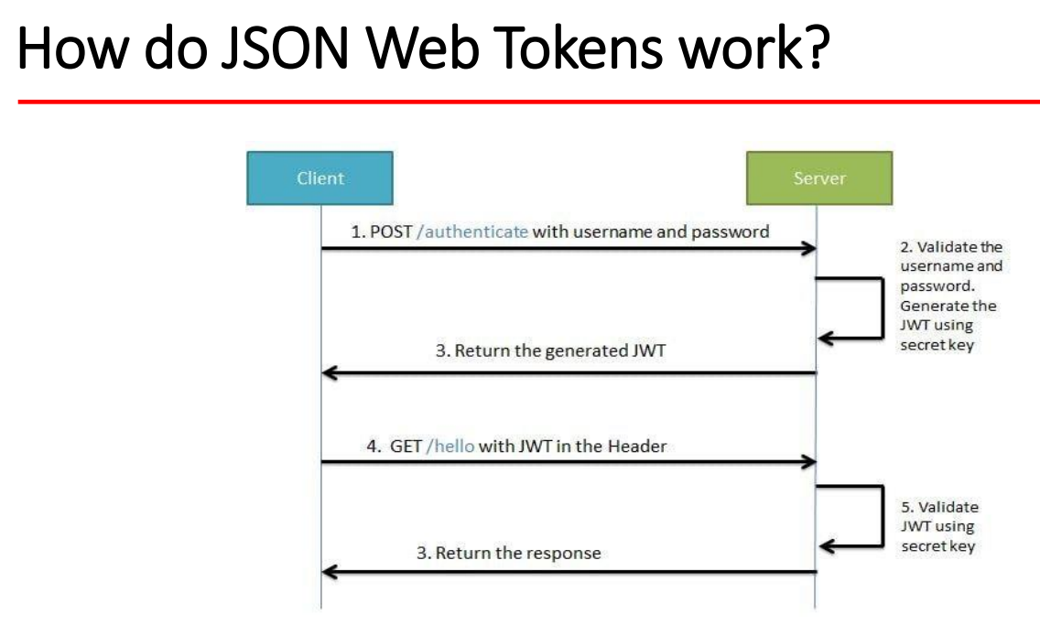

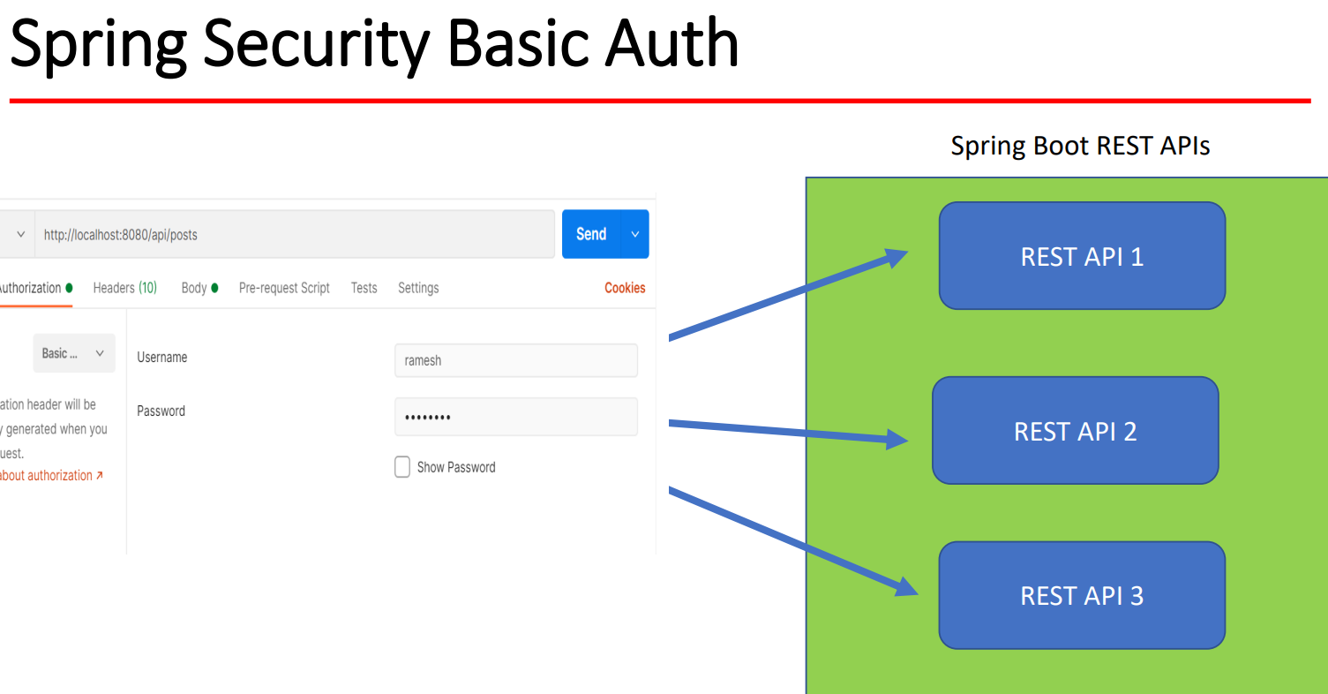

* Disadvantage :
* We need to pass every time username to password in request for accessing resources.
* If we want to get more resources in api then you need to give proper authentication username and password every time.

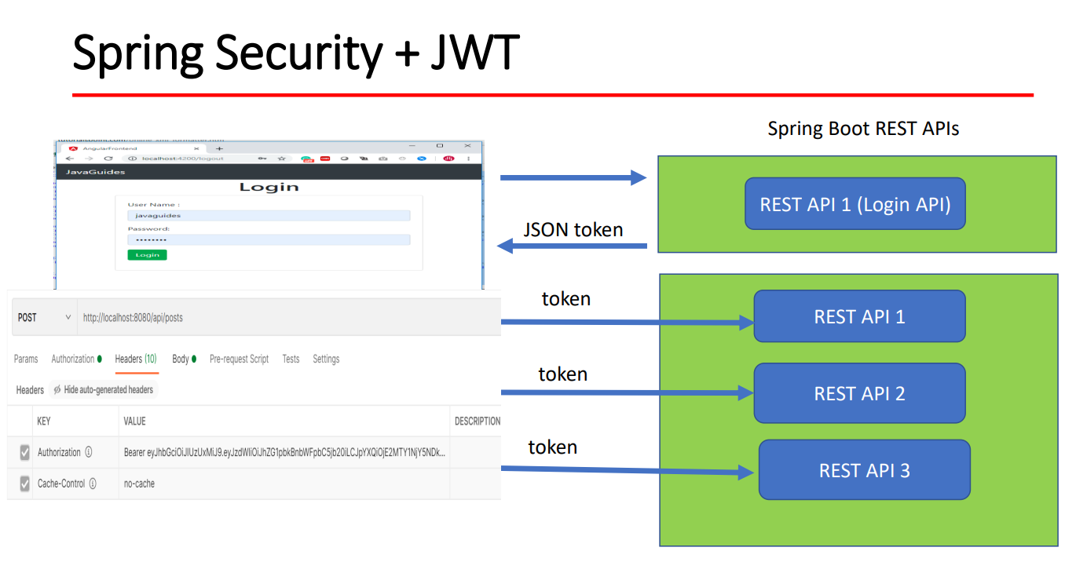

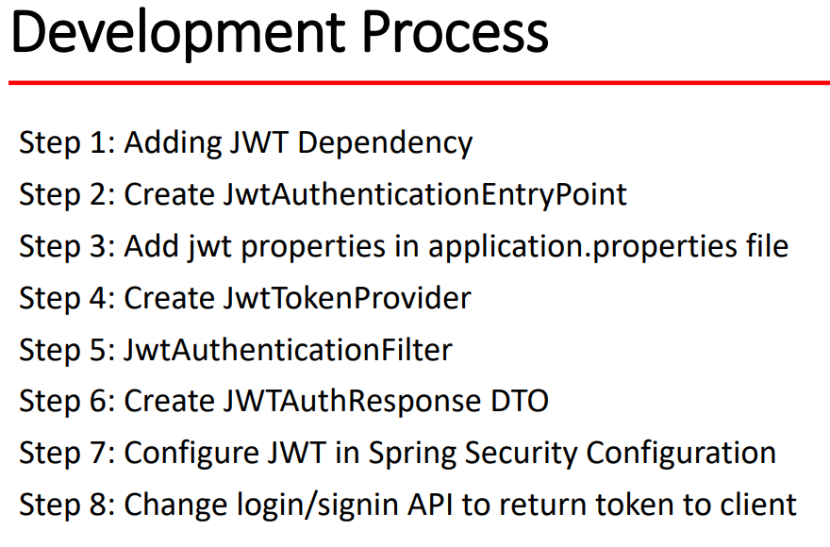

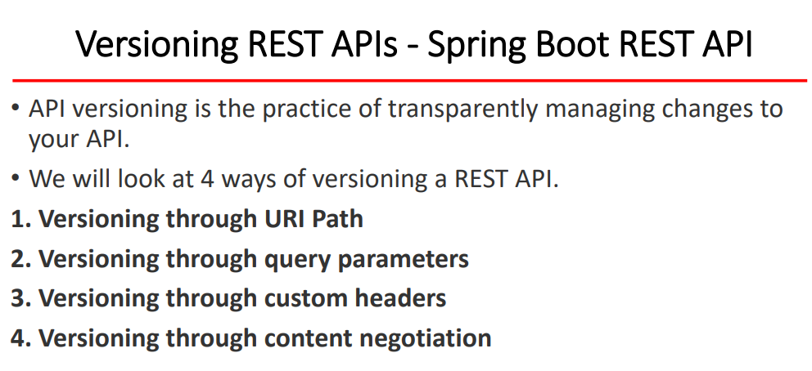

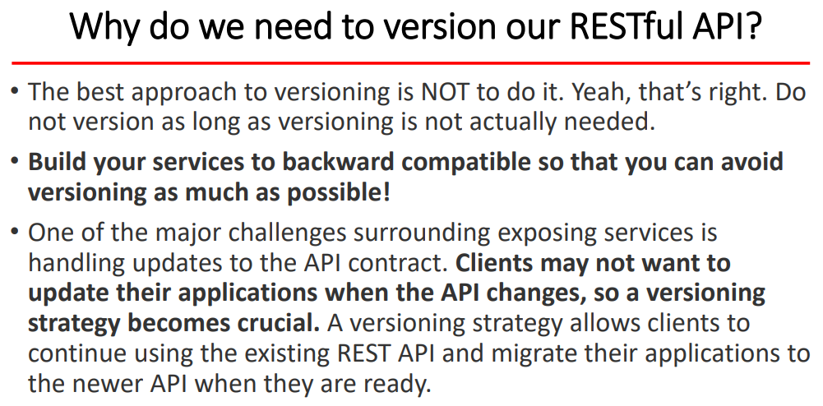

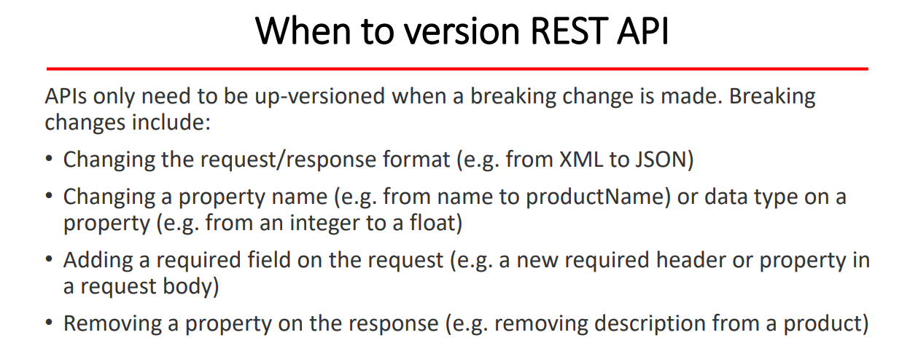

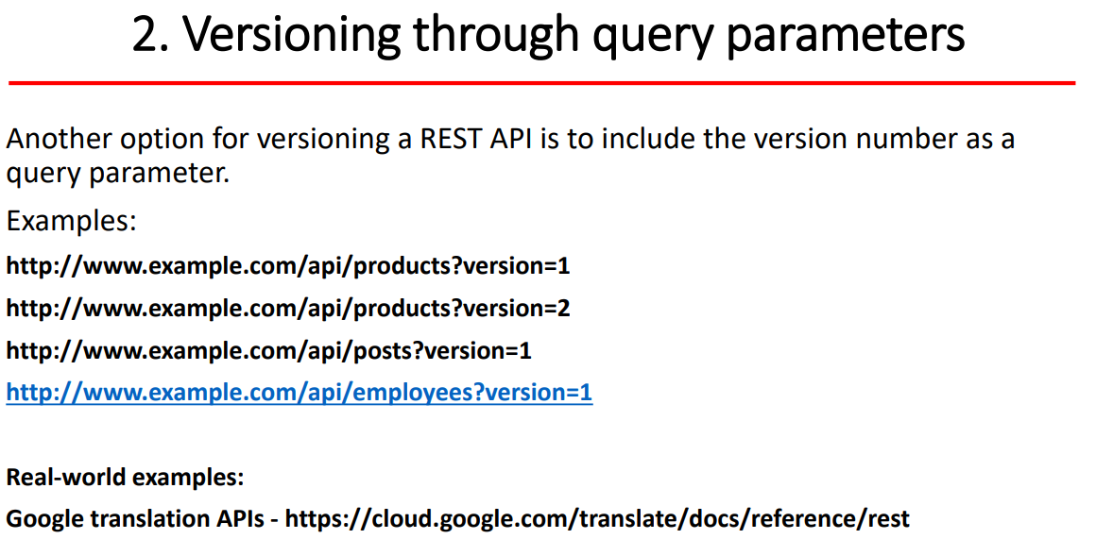

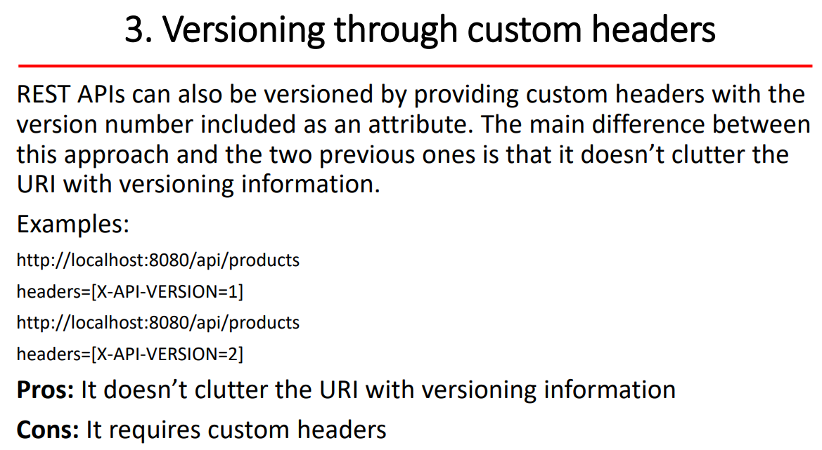

Swagger :

<http://localhost:8080/swagger-ui/index.html>

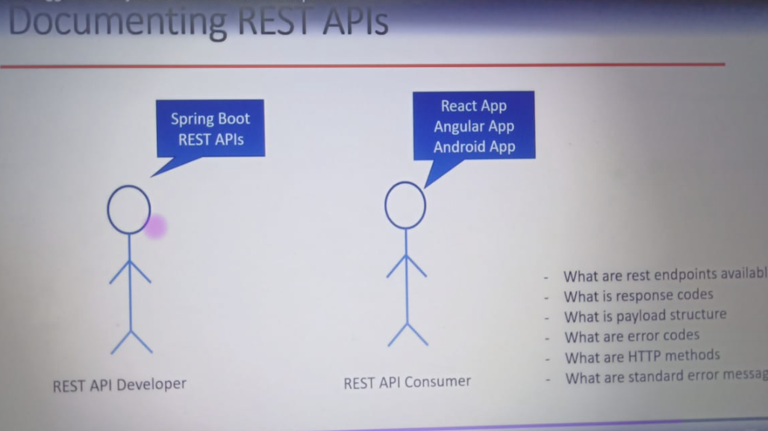

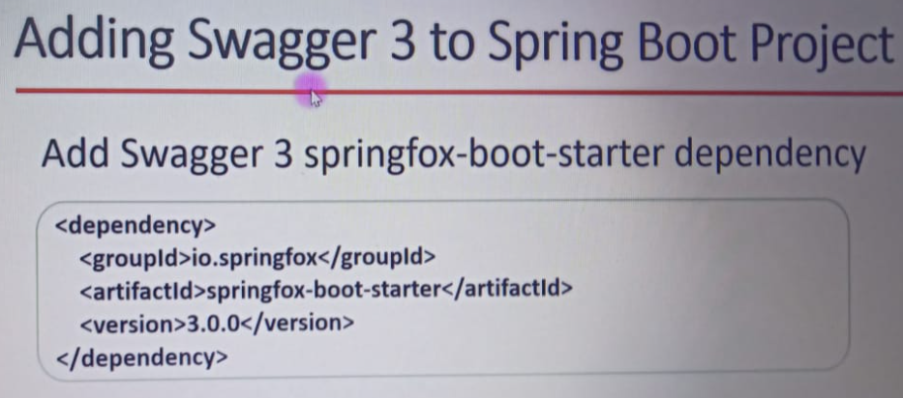

<dependency>  
<groupId>io.springfox</groupId>  
<artifactId>springfox-boot-starter</artifactId>  
<version>3.0.0</version>  
</dependency>

